

Sema.ie

Project Report

Tatiana Zihindula

DT228

Computer Science

School of Computing

Dublin Institute of technology

08/12/2016

2016

Declaration

I hereby declare that the work described in this dissertation is, except where otherwise stated, entirely my own work and has not been submitted as an exercise for a degree at this or any other university.

Signed:

_________________________

Tatiana Zihindula

08/12/2016

Table of Contents

I. Problem description 3

a) Detailed description of the website. 3

b) Description of the archetypical users of the site. 8

c) Problem solved by the website. 10

II. Research 10

III. Technology Section and Site Architecture. 11

IV. Low Fidelity Prototype 12

V. Development Plan 18

VI. Testing plan 20

VII. Site Evaluation 20

VIII. Deployment 21

# 

# Problem description

## Detailed description of the website.

The website’s name is called ‘sema’. This word mean ‘talk’ in Swahili, and describes the content of ‘sema’ website. This is a Network provider-type website where all the products and services on offer have a focus on communication.

The tittle ‘sema’ is an inspiration of Apple’s default browser name ‘Safari’ which is a Swahili word, as well as the Author of the website ‘sema’ who speaks the language.

The website is made of five functional webpages. They all have three main part. The header, the main contain and the footer. The footers are all identical on all the pages, but the main content as well as the headers, change according to the user’s need.

1. The **index.html** page

This is the main home page. It contains three main parts: **a big header**, spanning on the viewport width and viewport height of the browser. It includes a navigation bar, the website’s logo, a gallery of rotating pictures, as well as few other links that the user might find useful.

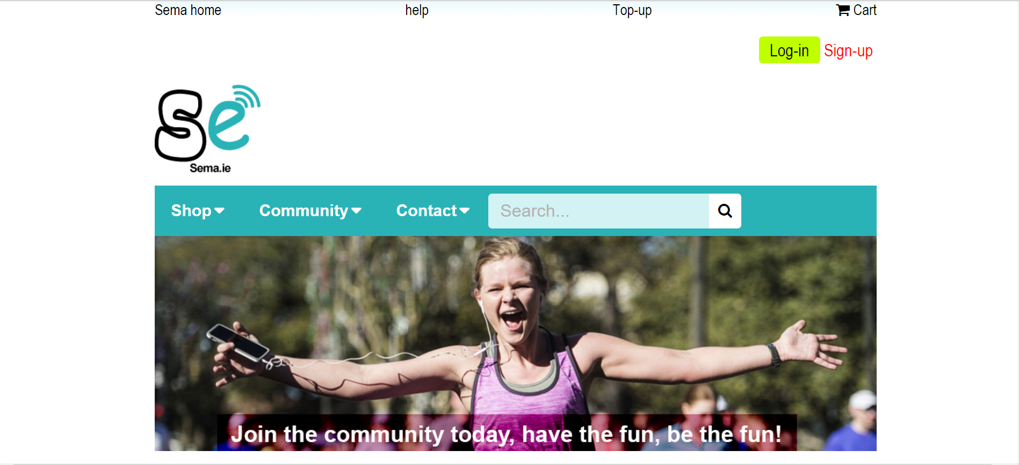

The index.html is also a place where the customer can **buy products, or learn more** about possible offers and discounts on certain products such as accessories.

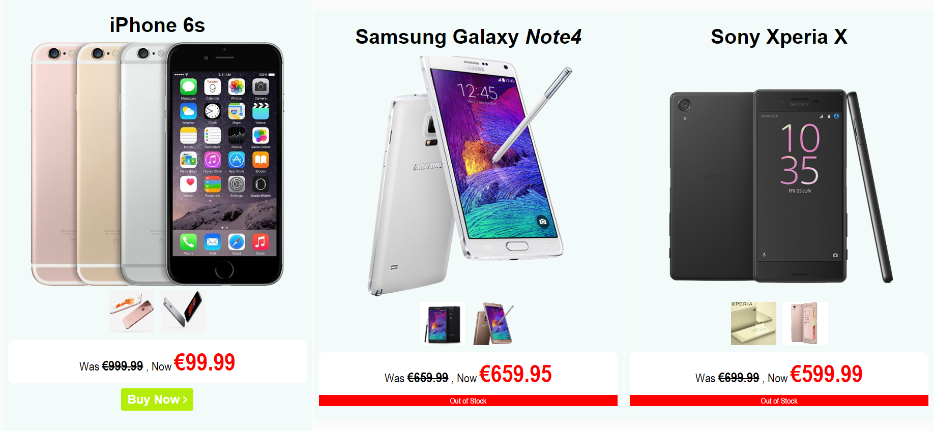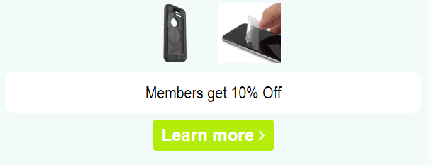

**A big footer** present on the index.html page, is also present on all the other webpages on the website. This is to compensate the amount of services that a website of this kind might have to offer.

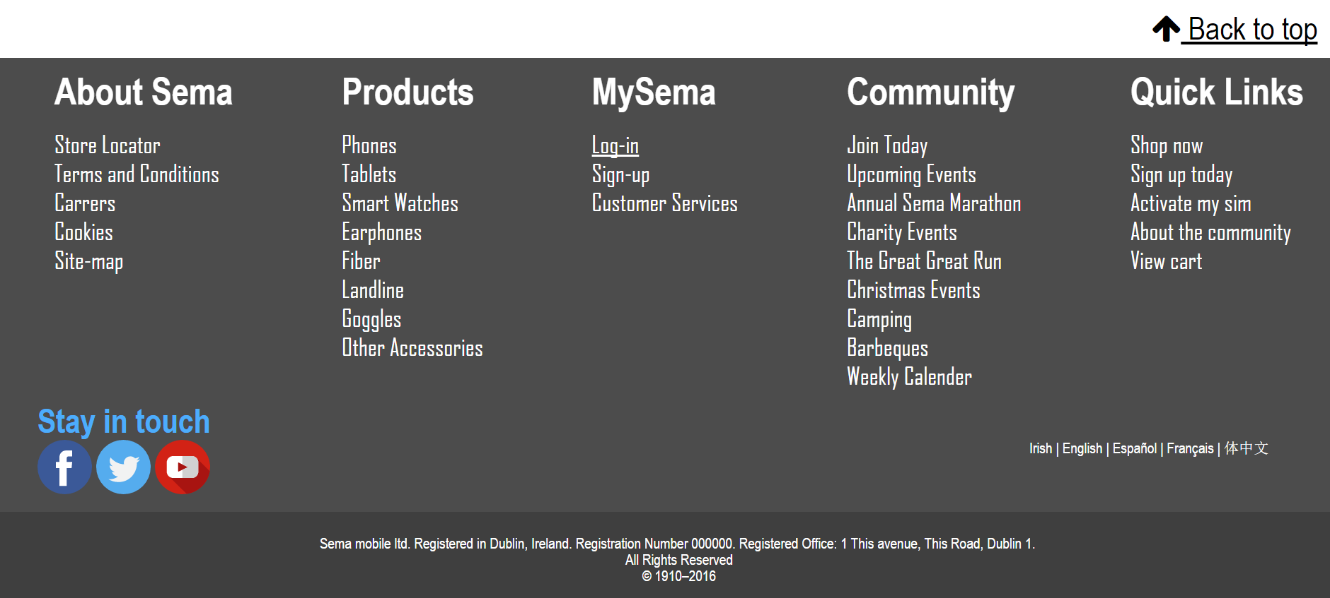

Not all the links inside the footer are functional though, as this project is more of a demo, but those that work can be accessed in the **Quick Links** inside the footer on each web page.

1. The **add_to_cart.html** page

This page is where the user gets directed, when he/she wants to add something to cart. The page gives a set of useful information concerning the product that the user might have selected, as well as suggest him/her other products related to the chosen product.

On the index.html page, the only product that can be virtually bought is the **iPhone 6s**. This is because the other products in this website are marked out of stock. When the ‘Buy now’ functionality is clicked onto, the user can then select further option before adding this item to the cart if he/she wishes to.

This page contains 4 main functions.

1. The **additional information button.** When this button is clicked, a hidden table is triggered in order to give the user additional information about the selected product. The user can choose to hide it when he is done with the functionality by clicking on **‘ ^ hide’.**

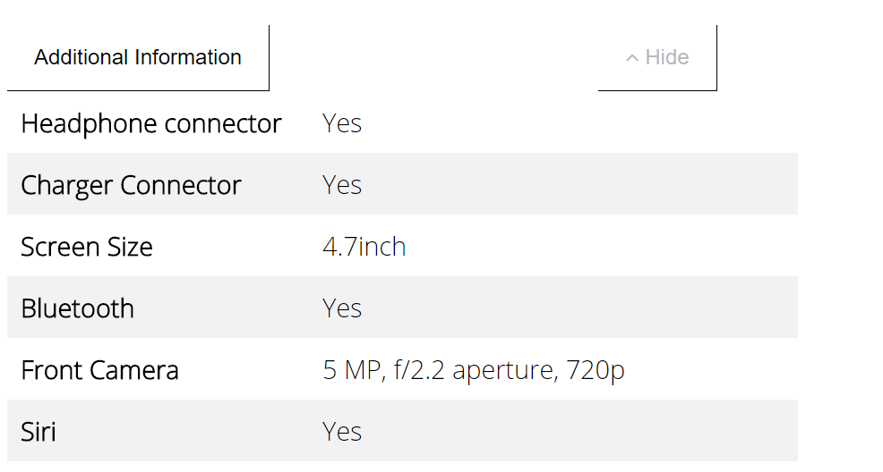

1. The second functionality offered by add_to_cart.html is the **gallery**. By clicking on the images on the left, the user can replace the image on the right to have a full preview of the clicked image.

Click me on the website

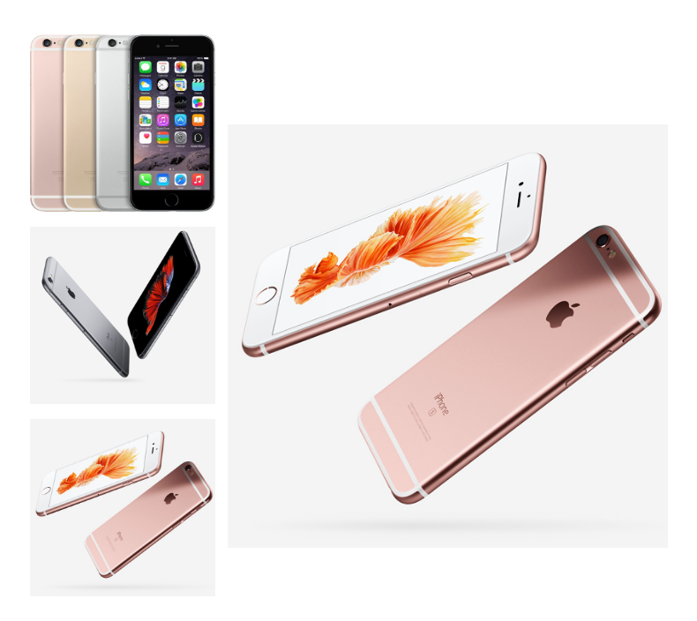

1. On add to cart the user can also be informed on other products that are related the product he/she selected to buy. This information can be found on the frequently bought together part inside this webpage.

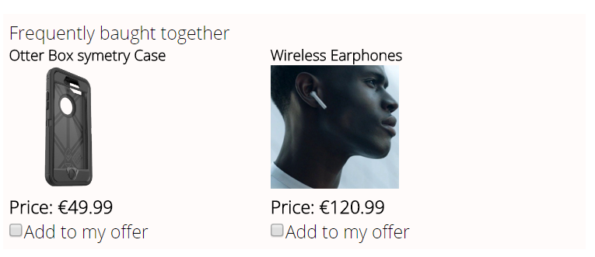

The buyer can add more items to the offer if he/she wishes to. When this is done, the final total of the cart is updated accordingly.

1. The last functionality offered by the cart page is to finally add the item to the cart. This is done after a selection of certain characteristic of the product, such as the colour desired, the storage capacity… This enables the system to keep a detailed description of the product to be bought.

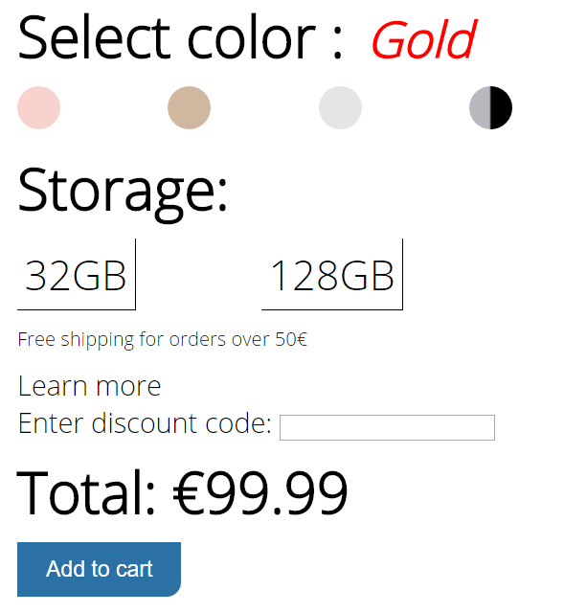

1. The **activate_my_sim.html** page

This page contains a big header similar to the one on the index page, as well as a simple form that the user must correctly fill, using the information provided on his/her sim card holder.

The aim of this webpage was to mimic a real-life experience where the user will have to use external material before filling a form.

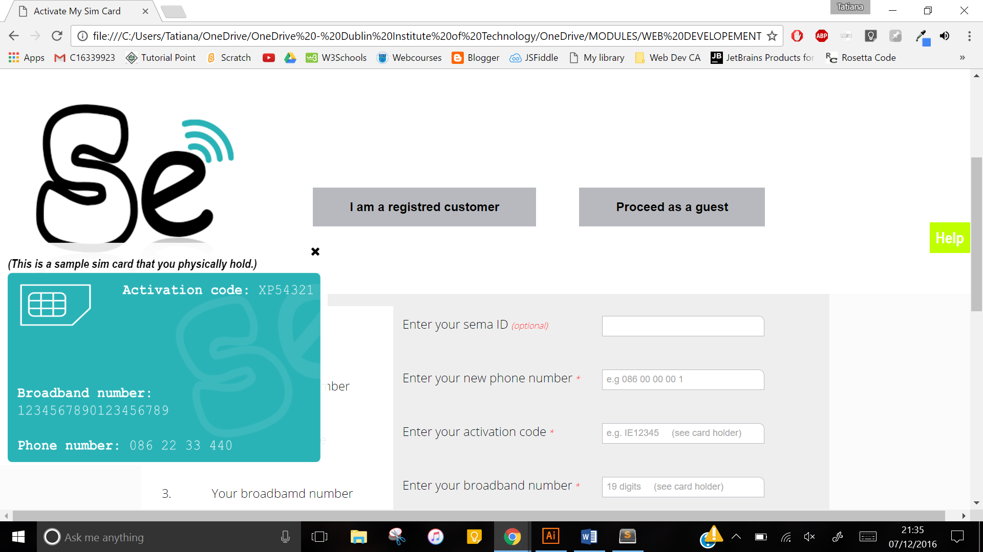The user **must click on the help** **box** to view his/her sample card. This card will then be used to fill the out form. Entering the user ID on this form is not compulsory, as the fact that unregistered user might wish to also activate their sim cards has been considered.

Click on help

1. The **sign_up.html** page.

This page is where the user gets redirected if he/she wishes to sign up. This page contains one form with areas that need to be filled, as well as others that are optional.

If the user fails to enter the required input such as a valid 10-digit phone number, matching passwords or a valid e-mail address, he/she will be notified to do so.

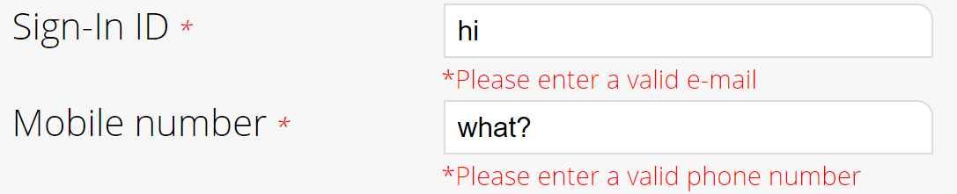

When this form is filled successfully, the user get his/her email unregistered as hi/her sema ID. The user also receives a discount code that he/she can use to get discounts on products and services.

1. The **community.html** page

The community page is slightly different from the four other pages from its content to its design.

The community page holds information about the advantages of becoming a member of the website or the community. The aim of this website is to encourage unregistered user to sign up.

This page also includes a weekly planner, which is timetable of upcoming activities or even on a seven days basis.

The community page header looks as follow:

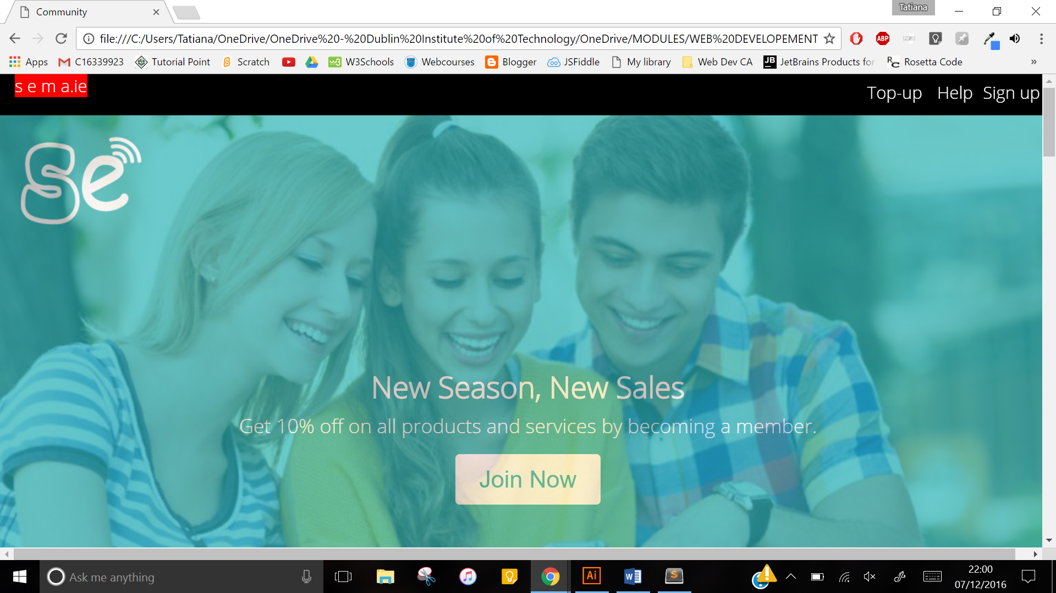

## Description of the archetypical users of the site.

The archetypical users of ‘sema’ website is the member of the general public regardless their age, studies…

These users of the website can be parted in two main categories which are, registered users, and unregistered users. A registered user can also sign up for a loyalty card for further discounts. But before they do so, they must have a Sema I.D. or be registered.

Example:

1. **Mary is a registered user**, on this website she can:

* Buy a product
* Log-in to her mySema account using her mySema ID
* Have a discount code
* Get updated weekly about the upcoming events
* Activate her sim card
* Top up online
* Sign up for a loyalty card

1. **Paul is an unregistered user**, on this website he only can :

* Buy a product
* Activate his sim card
* Create a sema account

*(see user’s case diagram on the following page)*

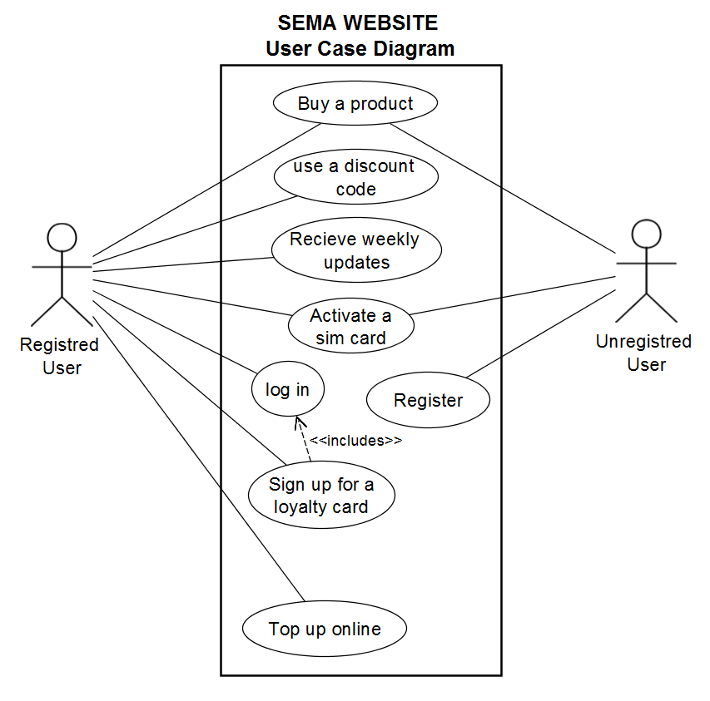

## Problem solved by the website.

Sema is a website that sells goods and services to keep its customers in contact with each other as longer as possible. This is made possible through the low-cost bundle it offers. This bundle includes unlimited calls, unlimited text, and free internet at only €15 a month. Sema gives discount codes to its registered customers, to keep them loyal.

Sema website also facilitate his registered user to take advantage of the online features it offers, such online top up, online shopping…

# Research

During the creation of ‘sema’, website offering similar services have been looked up. Other website that had an interesting design that would suit this website were also taken in consideration.

The main websites that I looked at were:

1. Three.ie Activate my sim card website: <http://www.three.ie/activate-my-sim/>
2. Meteor.ie website : <https://www.meteor.ie/>
3. Sony website:

<https://account.sonyentertainmentnetwork.com/liquid/reg/account/create-account!input.action>

1. Compub.com: <https://www.compub.com/iphone-6s-plus>
2. W3schools website: <http://www.w3schools.com/howto/tryhow_css_parallax_demo.htm>
3. Udacity.com: <https://www.udacity.com/google-scholarships?utm_source=email&utm_medium=email&utm_term=email&utm_content=cta1&utm_campaign=android_dw_ie>

The first website I looked at was the three.ie website. This website had a clean and clear layout with texts and picture on plain white backgrounds. This inspired me not to use too much unnecessary decoration on my page and to keep the design as simple as possible, while remaining effective.

This page was also useful when designing the activate_my_sim.html page. However, I did not like the way the user had to go through 3 sets of steps in ordered to activate his/her card. Thus, I decided to cut down the 3 steps in one and let the user enter all the required information on a single page.

The second website I looked at was meteor.ie. The big footer it had looked very informative and well layered out. Therefore, I decided to make a similar-type footer for my website.

Both three.ie and meteor.ie sold products on their home page. And as I was doing a similar website, I decided to also sell products on my index page.

The third website that came in handy when creating sema was the Sony registration form. When I saw this form, I was immediately amazed by its simplicity and slick design. It didn’t seem too complicated to style but it would come to be a bit challenging to validate.

The fourth website looked at was compub.com. This website also sells mobile phones as part of its product lines. When I was consulting it, I was amazed by the sleekness and the layout of items on it. Creating a similar layout for the products on my website will later on become one of the biggest challenges I had to face during this project.

While applying for a google internship, I stumbled on my fifth page. I was fascinated by the cover picture I found on audacity.com. The colours used on this website were similar to the ones used for my home page. Therefore, mixing this colour theme with the parallax effect I previously learnt about on w3schools, I was able to create the community page.

The last website that largely contributed in the creation of this website is the w3schools through its online tutorials.

# Technology Section and Site Architecture.

The website is designed with Html5 and styled with CSS3. Being the latest versions of their kind, they enabled the website to take advantage of the latest features they offer, such as the <section> tag, the <header> in Html5, or the use of **flexboxes** in CSS3.

The design of sema was inspired by simplicity and clarity. A **turquoise** colour theme on a white background was chosen to keep the appearance of the website less overwhelming and clearer. The content of the website is classified in containers, mostly divs <div>, labels <label>, spans <span> and sections <section>, to facilitate the styling when using CSS3.

The responsive design of the website has been optimised using by appropriately using CSS proprieties and value. For example, using percentages, instead of pixels for sizing the containers on the webpage. In parts where the layout was not cooperative with the size of the screen, CSS media queries were used to make the layout more responsive.

By including the Html5 viewport meta tag

<meta name="viewport" content="width=device-width, initial-scale=1.0"> in the header of the webpages on the website, the **view height** and **view width** of every screen used to view the website could be considered as the sizing reference points.

The website is browser compatible for the majority of the features it has. This is because the architecture of the website uses simple CSS properties that are browser compatible to create the look it has. In the input tags, data of type=“date” were replaced by “text” for the **age** instead of the **date of birth** to maximise the compatibility.

# Low Fidelity Prototype

The first page of the website was created by following a high-fidelity prototype using adobe illustrator. This was to cut down the design time. The header and the footer were previously planned to stay static on each webpage, but this changed as the Autor realised that not all features on in the header are needed once the customer has chosen what he wanted specifically. For example, if a customer is on the webpage, she/he might not know where to find what he/she is looking for. Thus, a big header with links to website features might be needed. But when a customer has already chosen an option, such as ‘signing up’ for example, then the big header was not of good use anymore and therefore was reduced to a smaller bar. And if the customer had chosen that specific option by mistake, he could always click on the ‘sema logo’ in the middle of the header to return to the home page.

The two hi-fidelity prototypes used were for the header and the footer of the index page. They looked as follow.

1. **Header**

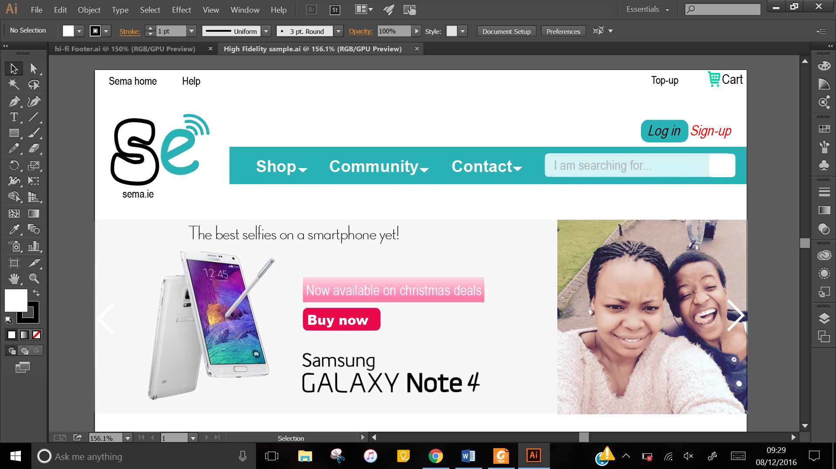

1. **Footer**

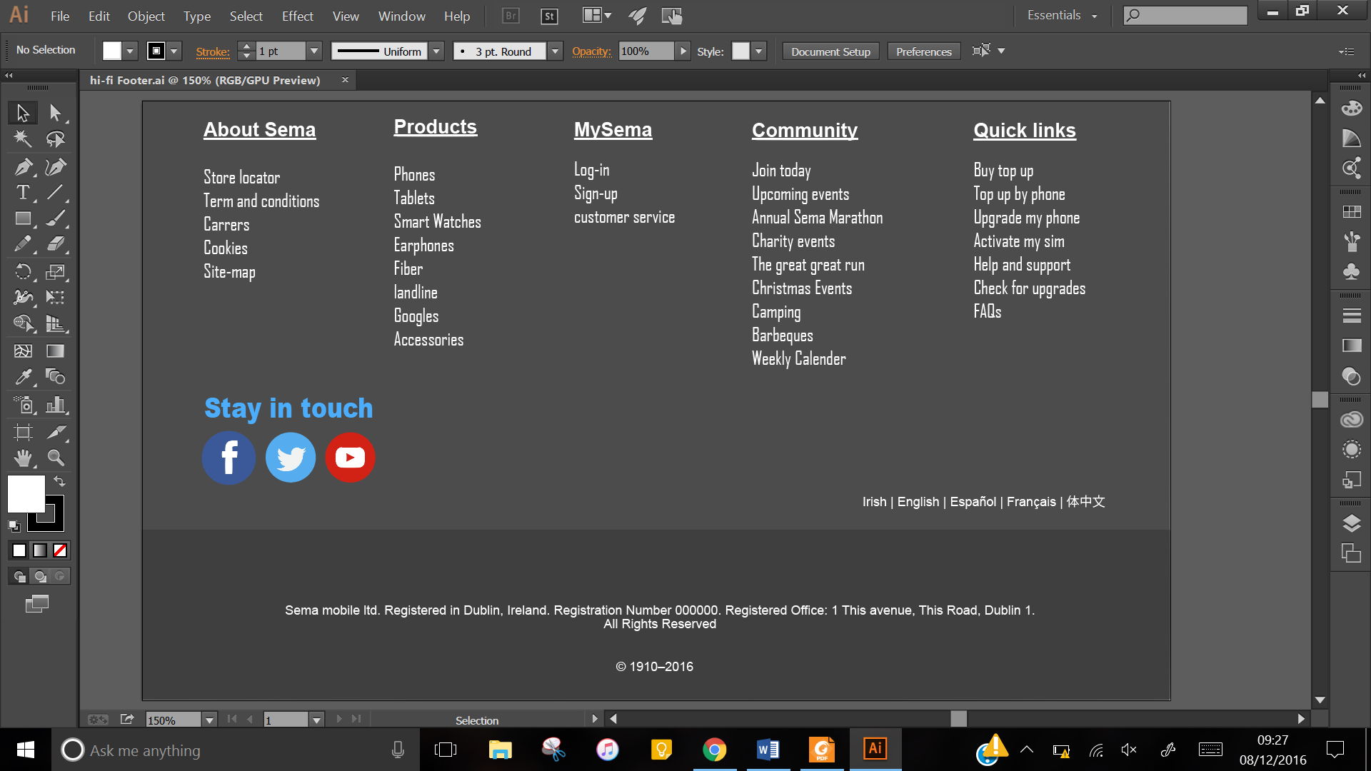

The purpose of creating a high-fidelity prototype was to be clearer on the Html5 tags and CSS properties that were meant to be used when designing the actual website.

For other stakeholders, only a low fidelity prototype was necessary to demonstrate various features that the website had to offer.

Eg. On the index.html page (home page), the customer might to know exactly where some features are, therefore, this page should be as informative and possible in its header section.

The index’s lo-fi prototype will then have the following features:

1. In the header top, links that the customer might use to find what he clicked on the website for, such as help, top up…

He/she can also log in or sign up if he/she wishes to. Then there is a navigation bar to direct the customer toward different sections of the website such as the community, contact… the customer can also view the images on the slide show inside the header to learn more about the website.

In the body of the index, the customer can view a gallery of products and choose either to buy them or learn more about the product.

Then finally there is footer that might contain links to direct the customer to further queries.

Below is a lo-fi prototype for the home page.

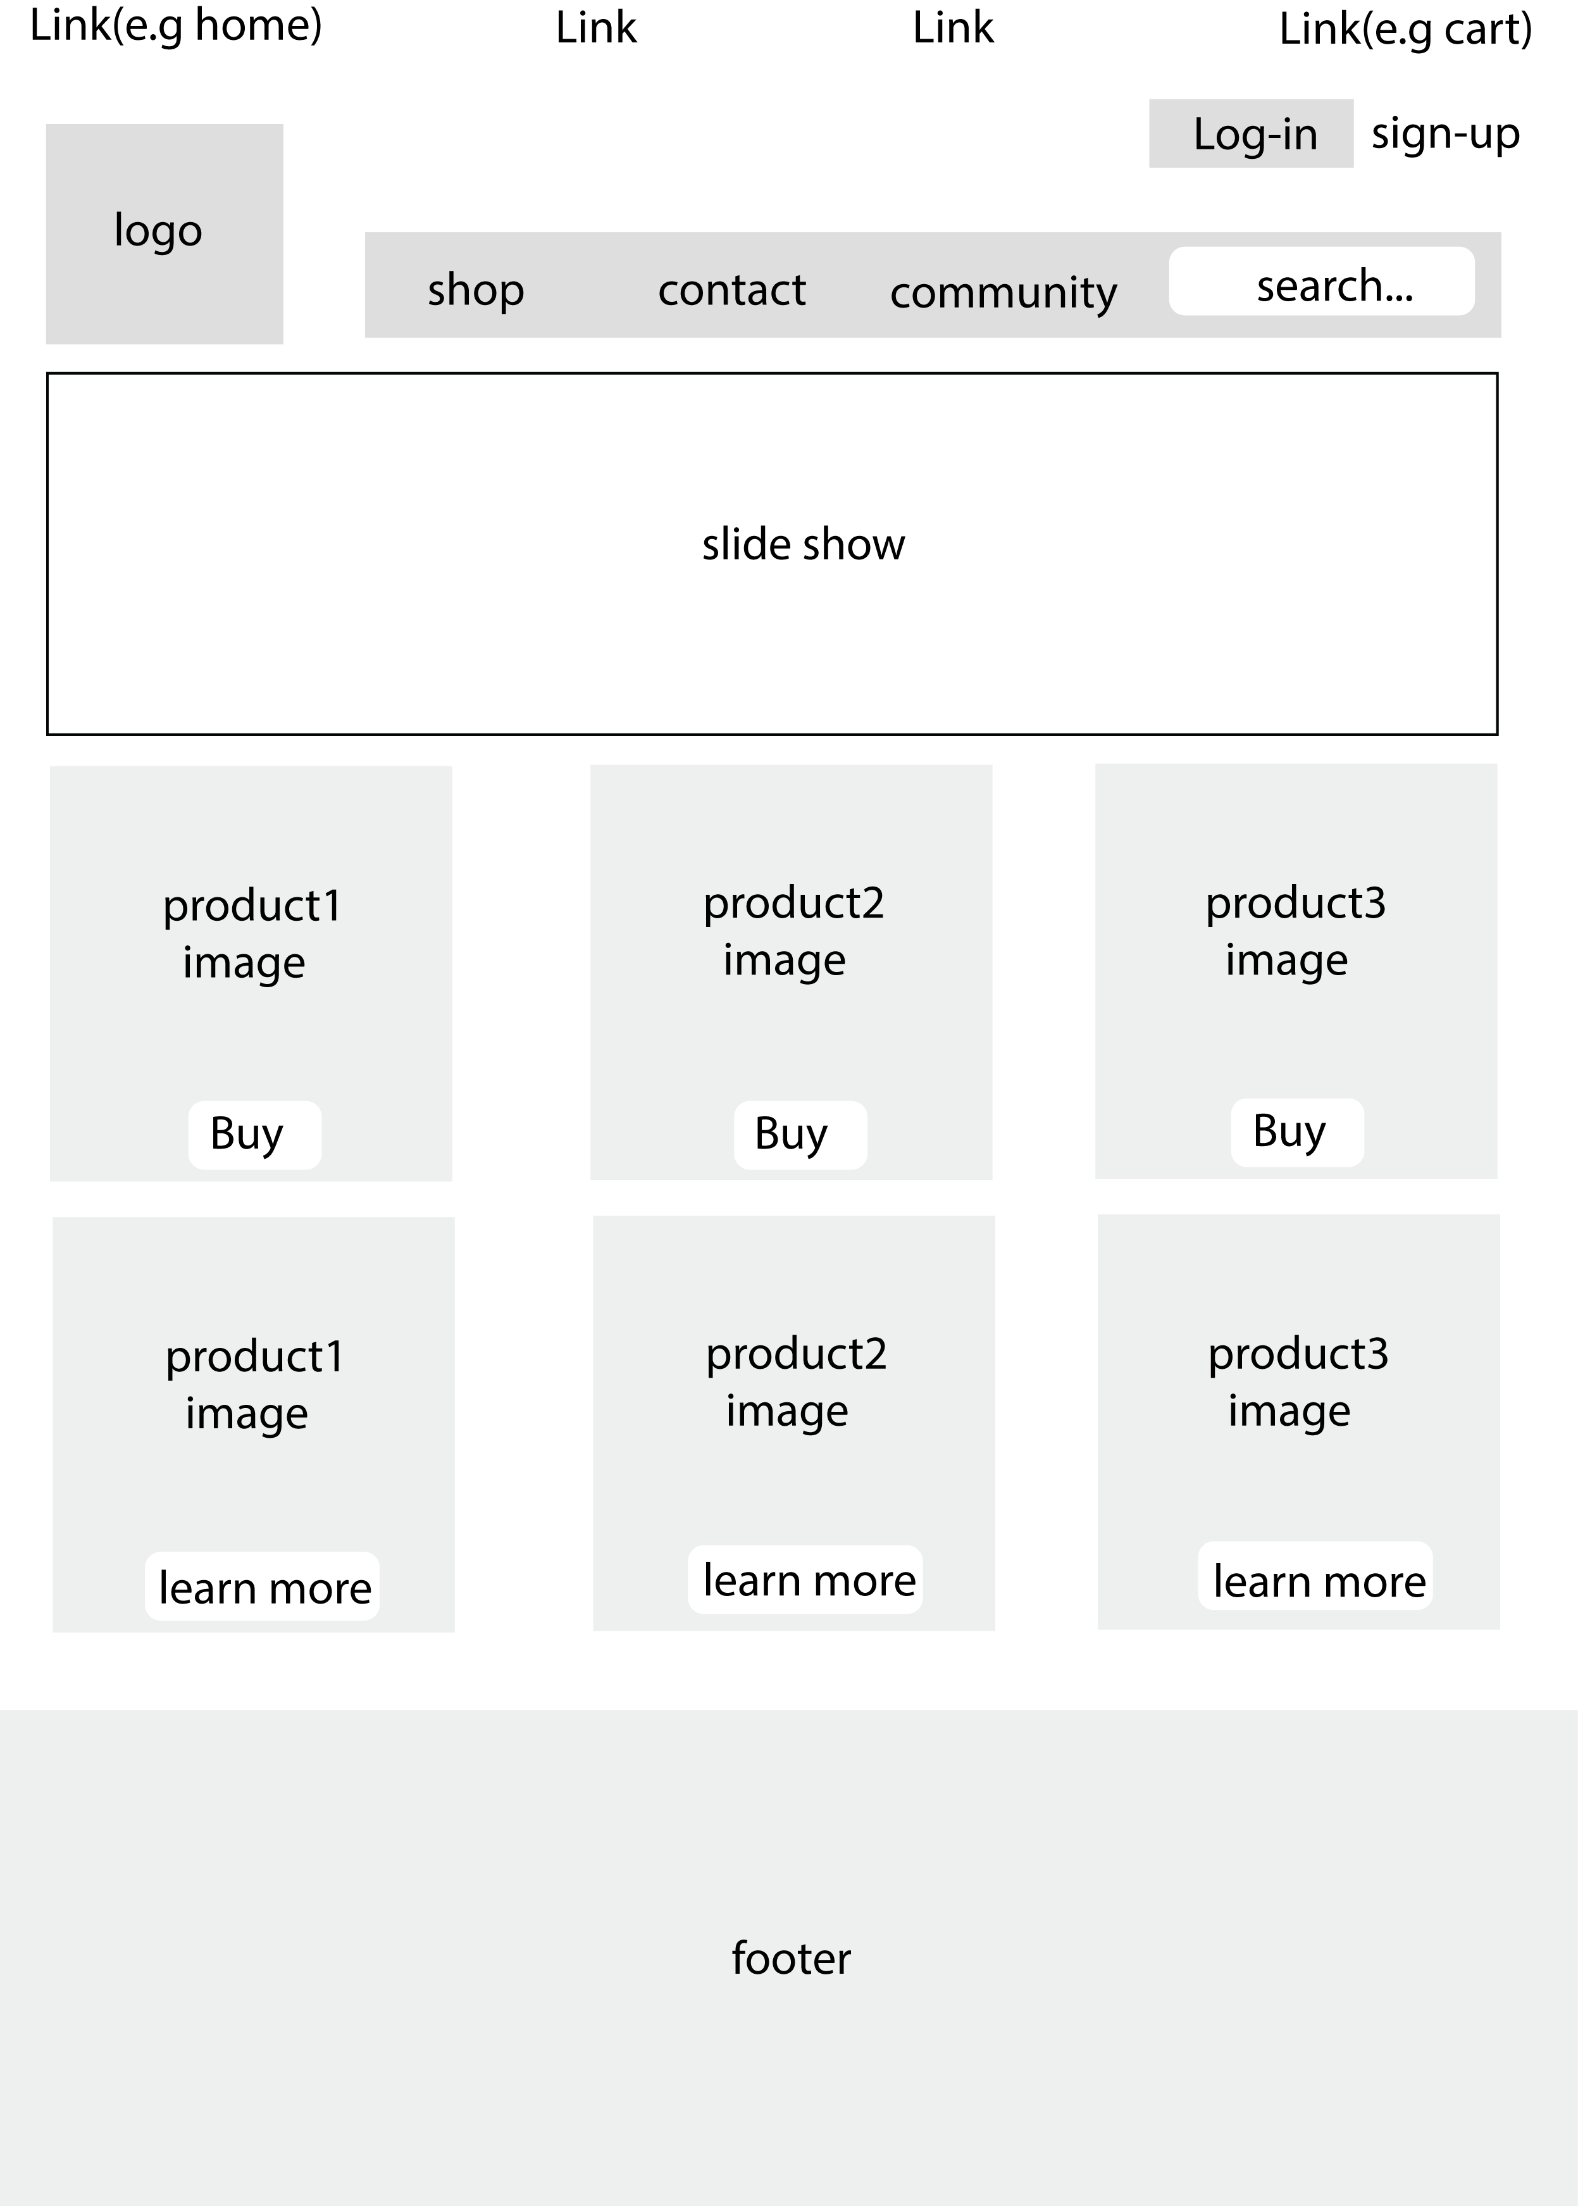

When the customer buys a product, he/she is directed to an add to cart page.

This page gives the customer in-depth information about the product chosen.

The customer can also be recommended related product that he/she can add to the cart if she/he wishes to.

Here is the lo-fi prototype of the cart webpage.

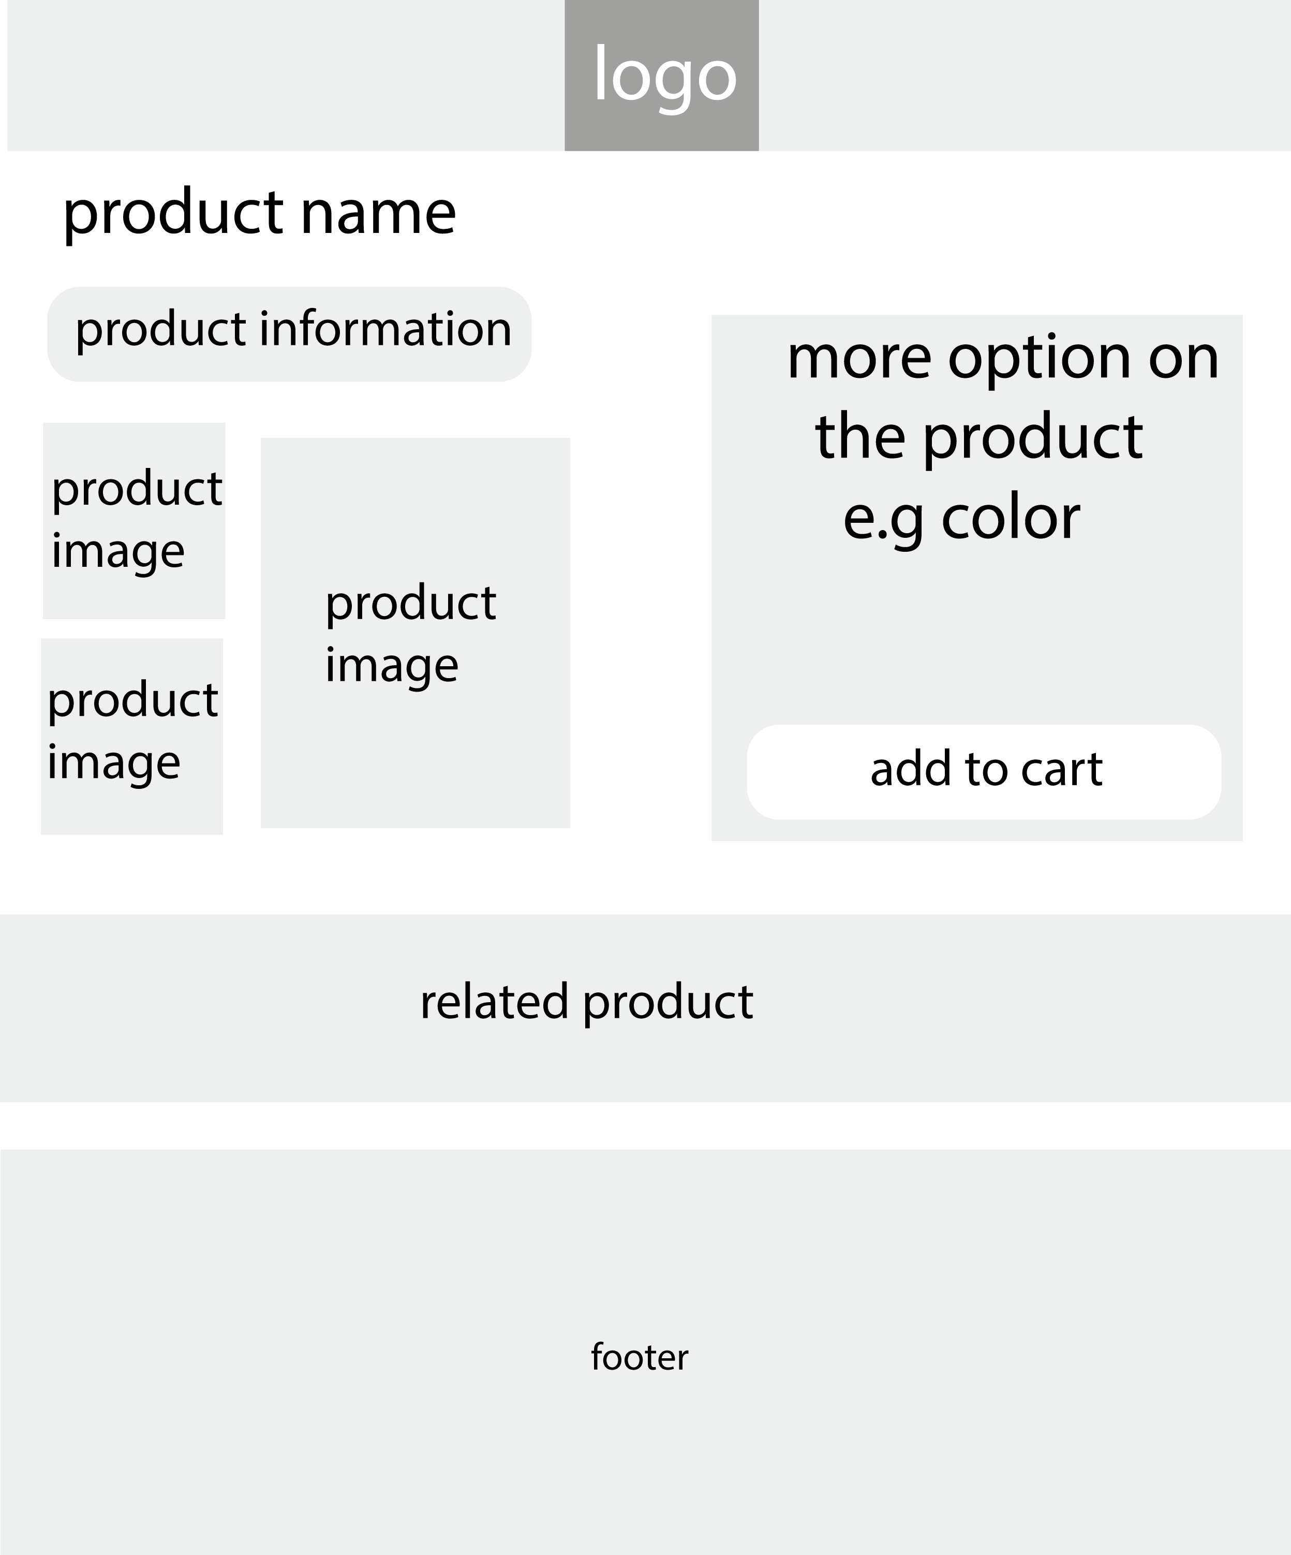

As this is communication website, the user can also activate his/her sim card if he/she wishes to. This will bring him/her to the activation page.

On this page, we assume that the user has bought his/her card in the shop, or online, and physically holds it.

Therefore he/she will just have to follow the instructions on the website and fill out the form.

As filling out forms might be tedious at times, a **help** button might be a good idea to help the customer filling this form without any issue.

Here is the low-fi prototype of the activate my sim page:

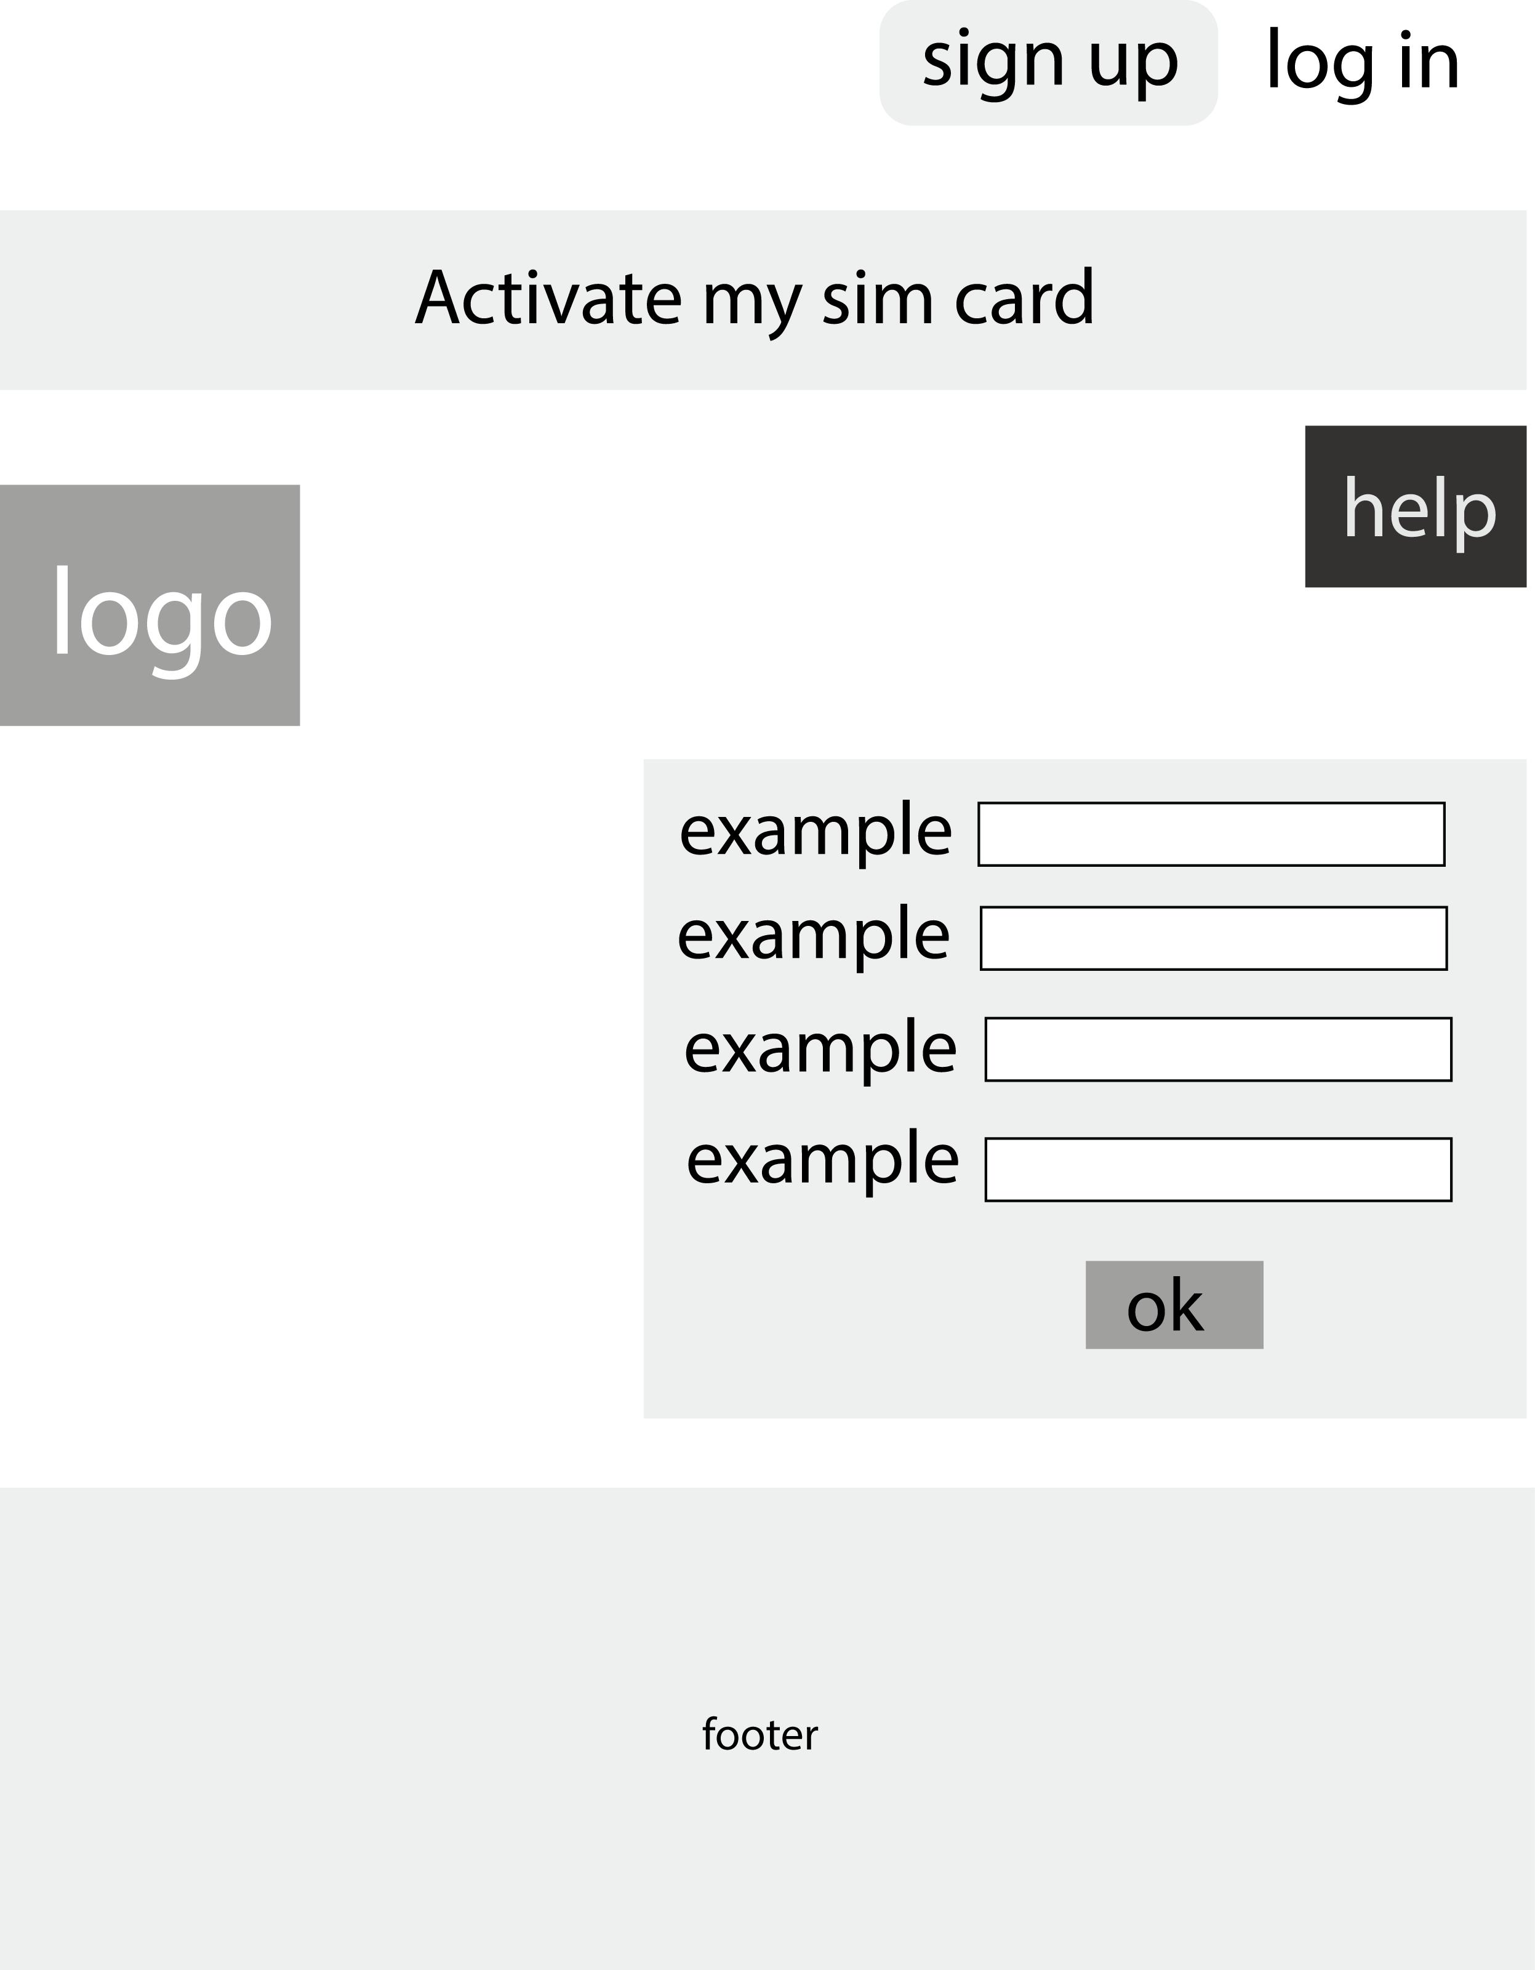

If the user wishes to sign up for the website, a sign-up form must be filled out as required. If the user is asked to enter their phone number, numeric values are expected to be entered. If they are asked to confirm a password, matching password are required to be entered.

If the customer has previously registered, there is a sign-in link there available if he/ she wishes to log in instead.

And if by any mean this page was clicked on by mistake, the logo in the header can still bring him/her to the home page.

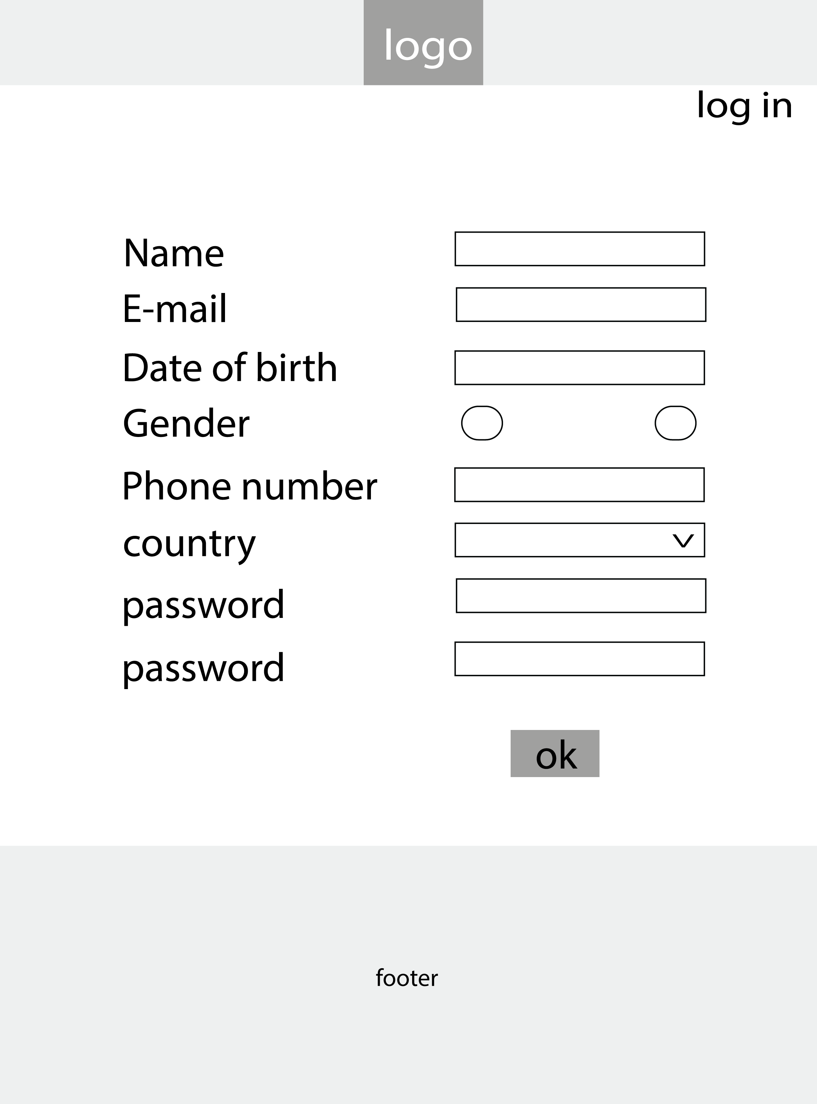

The last functional webpage on the website is the community page. The aim of this page is to promote the advantages that comes with signing up on the website. Such as getting discounts, weekly updates of the events, applying for a loyalty card…

This website also has a weekly planner of upcoming activities and event.

Here is its low-fidelity prototype.

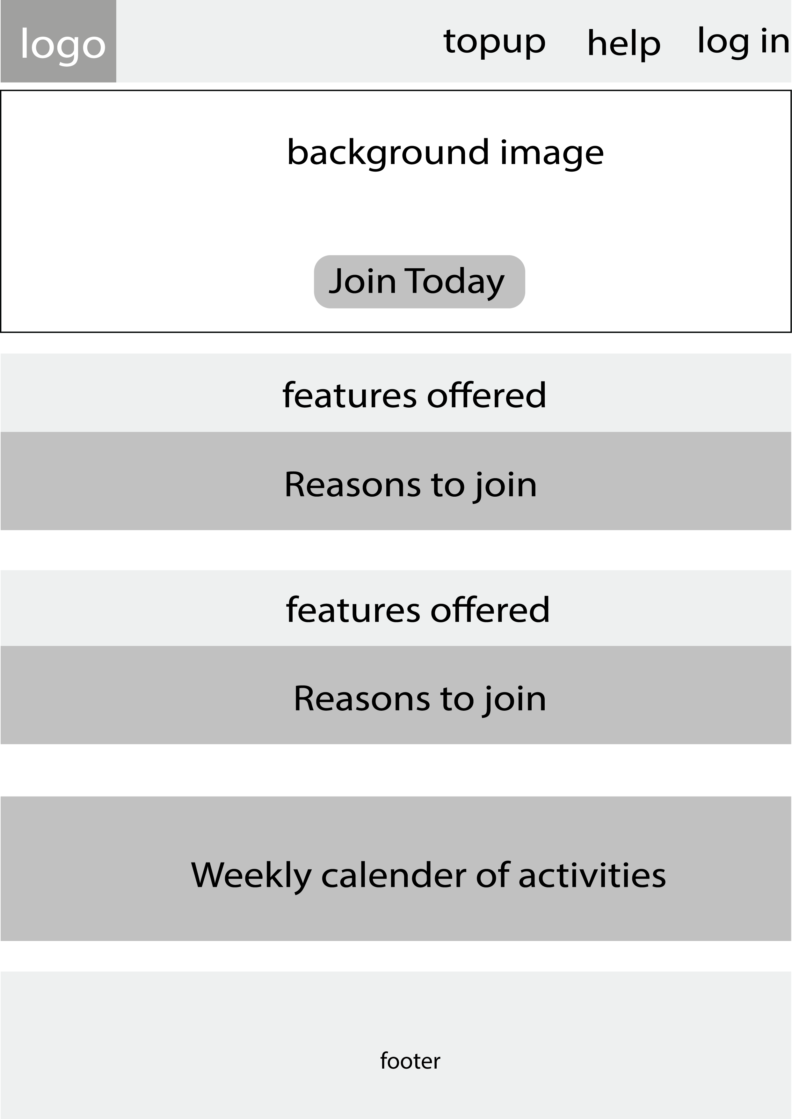

# Development Plan

The website was create using html5, CSS and JavaScript. At the start, .svg files’ code were planned to be used for icons on the website such as the ‘shopping cart icon’, the ‘direction’ icons on the navigation bar. However, these vector files were weighting the code with the .svg code itself and made the html document less readable. This readability issue was then fixed by using an icon font library found on W3schools.

Here is the font-awesome library link I added inside the head section of my webpages.

<link rel="stylesheet" href="https://cdnjs.cloudflare.com/ajax/libs/font-awesome/4.7.0/css/font-awesome.min.css">

Using these icon fonts to svg files was a breeze as I didn’t have to charge the page with extra lines of .svg codes.

These icons could also be styled like any other text on the website as they were fonts.

No other library was used except this one. Html5 codes were written first, then styled using CSS3 as the html5 documents were finished being written, or as they were written. JavaScript codes were added last to the website, as these last were meant to implement the features already created using html5 and CSS3.

While writing the JavaScript codes, I couldn’t always get it to work by using variables previously called outside of the functions.

After this issue was repeated several times, I decided not to use variables and go with the full statement instead.

For e.g. Instead of

Var first_name = document.forms[my_form_id][first_name_field].value;

Then call this variable later inside the code, I used the full path instead as I couldn’t always get the variable to work, while the full paths were working at all time.

The graphics (images) on the website were edited using Adobe Photoshop and Adobe Illustrator either simultaneously or separately.

The pictures on the website were obtained using Google’s search tools. Only images that were labelled for reused with modification were chosen. Below is the filter I used.

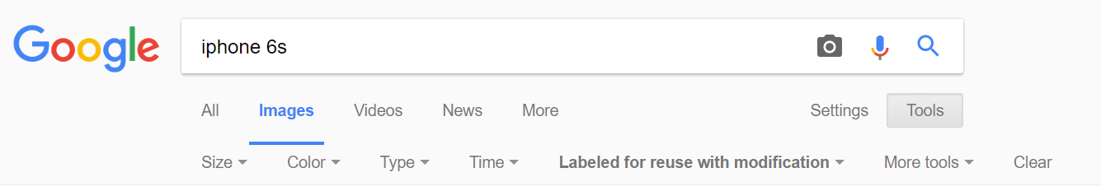

# Testing plan

All the html pages on the website have been validated using the mark-up validation services on <https://validator.w3.org/> . All the webpages are completely free from errors and warning except the **sign-up page** that had one error and one warning that could be passed. <https://validator.w3.org/> could not validate .css files claiming they didn’t have html or xml tags in them.

The website is browser compatible. It has been tested using Microsoft Edge on a Windows desktop and Laptop, Safari on an iPad, Internet on an android phone, and finally Google chrome on windows laptop.

The layout of the website stays consistent, and with the use of media queries, this planned to be optimised. For example, large pictures that look good inside the header on larger screens could have been reduced in size or simply removed on smaller screens. However, with limited time to hand, media queries were not fully added to the website.

See activate_my_sim.html for a demo.

# Site Evaluation

The testing plan was done by observing the way the users were interacting with the website and making changes accordingly. For example, 4 out of 12 users invited to interact with the home page had the tendency to buy all the products listed, when not all of them were available. Most of them did not like clicking on an unresponsive button. They expected a **buy now** button to bring them to a cart page or a checkout page. Since my home page only had 3 products on sale, I then used this feedback to mark the rest of the product ‘out of stock’ using JavaScript, then create an Add to Cart page.

By keeping the header similar on all the pages, 4 out of 6 users said it had too much information going on which made it overwhelming. Following the feedback received after an interview made when they were using the website, 2 of them suggested to keep the header simple on other pages that were not the home page. Taking this idea on board, I made the header on some of the webpages that were rather specific than informative clearer. A single logo would then be present inside the header to bring them back to the home page if they wished so. I also realised that this was a good idea as it would keep the customer focused on the option that he/she has already chosen. E.g. if he/she chooses to buy a product now, to sign up…

Help boxes are also present on delicate forms to help the user to find his/her way through certain features of the website. This can be evaluated on the activate_my_sim.html

The user was also given feedback after using certain functionalities on the website. For example, if the user entered an invalid email, he/she was asked to enter a valid one. When the item was added to the cart, he was notified of the action via an alert created using JavaScript.

The overall content of the website is displayed simply and clearly. This is made possible with the simple, but effective design used to create the website. 6 out of 6 people interviewed said they found the design simple, they loved the colours and the overall layout. Many described the website as “professional looking”.

# Deployment

The website was made available online using <https://www.000webhost.com/cpanel-login> . This is a website that offers free hosting services. They also have paid plans but his website was hosted using the free plan.

After creating an account, I had to upload my files on this hosting site and they could be accessed through the absolute path link generated after all the files were uploaded.

Folders were not allowed; therefore, I had to create new folders and rearrange my files accordingly.

The strategy used for search engines optimisation are the HTML5 and CSS3 Validations, and <meta> tags in the header of my webpage that describes briefly what it does to easily be found in different search engines.

Below are the <meta> tag used to describe the website.

<meta name="description" content="sema is a network provider website where customers can buy top up, buy phones and their accessories, activate their sim cards, and join the community, or sign up. Sema offers discount codes to its registered customers. Sema also organises activities every week in order to keep its customer’s worlds closer.">

<meta name="keywords" content="sema,phone,topup">

# Appendix

Web Dev 1

# Weekly Project Report – Week 9

Please provide a brief overview of the research or tasks that were completed on your project this week:

***10/11/2016***

In our Web development CA Semester one, we are required to use our knowledge of Html, CSS and java Scrip to create a website with a meaningful content, and 5 pages associated to it.

A report is also required to be written as part of the project, as well as a log submitted on a weekly basic, that should contain a detailed information regarding the progress of the CA, during that week.

**During this week**, I started brainstorming and collecting various ideas here and there that I judged to be helpful in my future website creation.

As I have a passion for Digital art, the first idea that popped inside my head was to create a website for a graphic design community, where designers could share their creations... But I quickly gave up on this idea as it seemed too centring to a specific group and especially less challenging as I already have some knowledge in graphic design.

After this, I then decided that I should create a **business website**. A banking, insurance type. One that will push my limits and get me to use html tags,CSS rules or java scripts codes in a way that I never thought of.

I have assembled few business websites, and added them to a special folder on the bookmark bar inside the chrome browser on my laptop.

I am still working on the title of the website, and I hope to have it by next week..

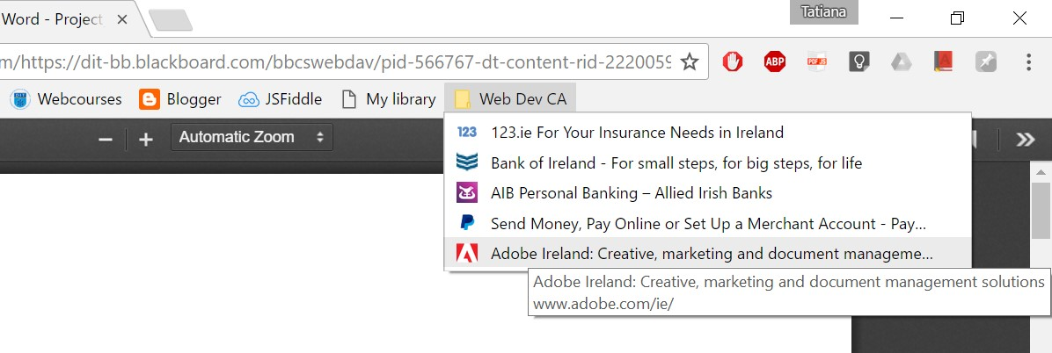Find below the screen shoot of the folder I created for my website reference .

Web Dev 1

Weekly Project Report – Week 10

Please provide a brief overview of the research or tasks that were completed on your project this week:

|  |
| --- |
| ***17/11/2016***    After attending this week’s Web Development Lectureon **“Forms, Validation and JavaScript”**, I became clearer on what type of website would be appropriate for the CA. The way I understood it, is that the website needs to be as interactive as possible in its 5 required meaningful webpages. The page should also use a variety of CCS rules to make it loop presentable to its type of audience.    Moulding the business website idea I had last week, I decided to limit my references to their appearances, and create features based on what I think my audience would need. CSS rules, JavaScript Codes and HTML tags used, should then be based on those needed features.    I am still hesitant about the title “Yellow” I chose for my website, but as time goes by, I will see how it goes with the website’s theme, and its overall purpose.    The idea of the website so far is a to create a **Net Work Provider Website**, but that also sells products and their accessories. ‘Yellow’ is more like a brand on its own.    This type of website should use a lot of forms that will enable me to use JavaScript, as well as a good variety of CSS rules to make it more presentable to its audience.    I have spent most of this week designing the website and deciding on how I should put the features of the website together, to suit its the audience. I have also been watching YouTube videos to implement those ideas.  e.g videos on how I could create a search bar, a transparent drop down menu…    *\*There is a design draft inside the zip folder containing this file. Please look it up for more concerning the design.* |

Web Dev 1

Weekly Project Report – Week 11

Please provide a brief overview of the research or tasks that were completed on your project this week:

***21/11/2016***

This week, I have been working on implementing the features and the layout I designed last week with an HTML structure .

The website’s title has changed from ‘Yellow’ to “Sema; a Swahili word that means ‘talk’”. The website’s purpose stays of a **Net Work Provider Website**, that also sells communication products.

I started implementing the codes I designed last week using Notepad++, but I stopped and decided to create a High-Fidelity prototype first, to cut down the coding time, as while coding, I found myself unsure on how exactly I wanted the website to look.

During the design is when I became clearer on the title of the website.

I was also inspired by other websites that have the same purpose as mines such as three.ie, Vodafone.ie, meteor.ie…, or other that simply had features that I found interesting, useful, and challenging.

I used Adobe Illustrator to design the content of the Prototypes from the logo, to the rest of the composition. I also downloaded few .svg icons from <http://www.flaticon.com/free-icons/> in order to implement the design.

The experience I had using vectors with illustrator compared to pixels(with photoshop), inspired me to replace all the icons I planned to have inside my website with . svg icons. I will only have to clear the backgrounds of the images I download Using Photoshop.

By next week, I should have all my 5 pages looking like the ones I designed, while each of them having its own content.

*\*Please find the Hi-Fi prototypes inside the .zip file containing this document.*

Web Dev 1

Weekly Project Report – Week 12

Please provide a brief overview of the research or tasks that were completed on your project this week:

***01/12/2016***

This week, I have been creating the websites that I designed last week with adobe Illustrator.

I have 4 pages designed in Html and fully styled in CSS. Those pages are:

* Home page
* Sign-up
* Adding item to cart (buy now)
* Activate your sim card.

I am left with one main page which is the community page. This page will be designed a bit differently, and will also include a weekly calendar of activities.

This calendar should allow me to use rowspan and colspan.

Aside these 5 pages I plan to have few short pages to implement the functionalities of the website such as the contact page, help page and few more feedback pages.

All my pages have many links from the fact that it is a Commercial Website, but only few are functional. These can be found in the ‘Quick Links’ part inside the footer. They will also be highlighted in the Rapport.

The design plan of the website has slightly changed. Last week I planned to only use vectors for icons, but I discovered something even better. I discovered the Font-Awesome *family-font.*

.svg files was a great discovery but the amount of codes that comes with adding its code to the html document is very pricey.

Thanks to [www.w3schools.com](http://www.w3schools.com) , I was able to discovered in the ***icon section*** that **font-awesome** icons could be used in place of vectors.

This completely revolutionised my coding and dramatically improved the visibility of my html documents.

All I had to do was to import the font-awesome library in the header of my html page. At first I was defiant using any library, but it really worth it as font-awesome were simply icons treated as text, they are just as flexible as .svg files for styling, if not better.

.svg files might be suitable in other projects but for now, ***font-awesome family font*** have everything I need.

*Please see on the next page the images demonstrating the difference in the use of the font-awesome icons in place of .svg files*

**Before** : Using .svg files

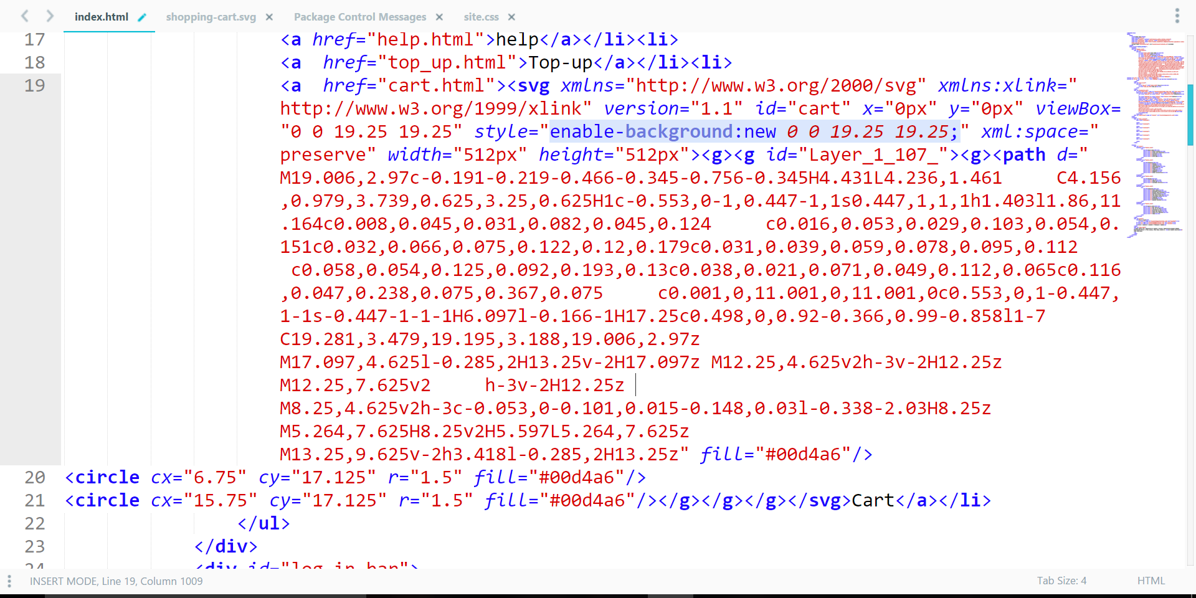

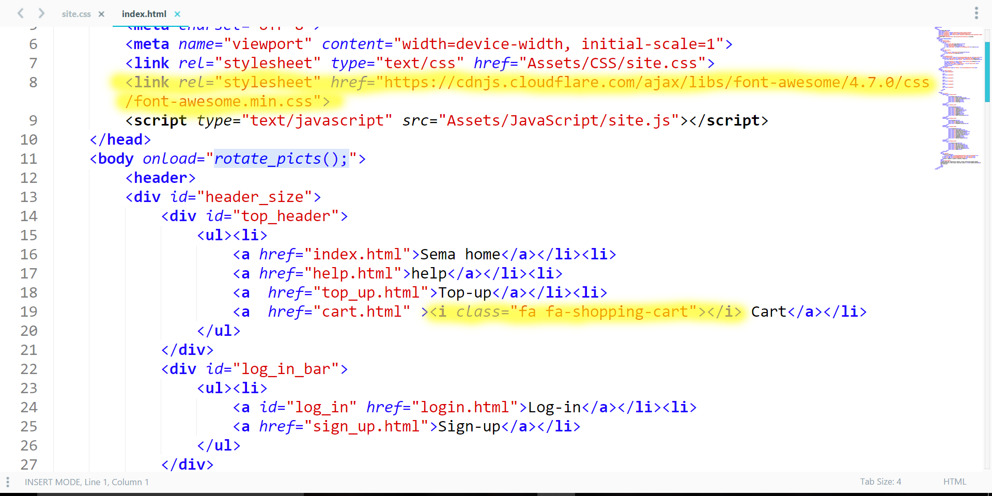After : using **font-awesome** icons <i></i> and **Library**